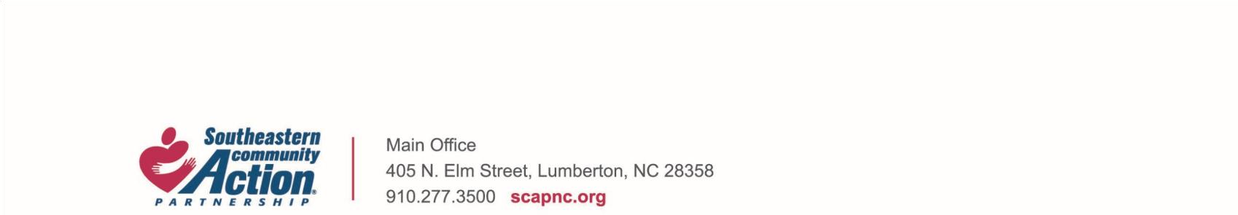**JOB DESCRIPTION**

|  |  |
| --- | --- |
| Title: | Head Start Assistant Director |
| Status: | Exempt |
| Terms: | Permanent Full Time |
| Department / Location: | HS/EHS Administration / Lumberton, NC |
| Reports To: | Head Start Director |
| Job Summary: | Responsible for coordinating, monitoring and implementing of the Head Start Program. Ensures that established agency policies and procedures are strictly complied with. Plans, organizes, and implements activities vital to the program. Ensures that the objectives of the unit are met as required. Guides and supervises all Program Specialists and Maintenance Supervisor in the performance of their duties. Provides training for staff. Maintains records of confidentiality. In the absence of the Head Start Director make sure that the daily operation of Head Start runs efficiently, such as signing of time sheets, requisitions, bills, handling any situation that needs to be addressed immediately, etc. As well as any other assigned duties. |

**Essential Duties and Responsibilities:**

* Identify potential issues through analyzing data.
* Works with the HS Director to coordinate and supervise daily operations.
* Acts as a liaison between the HS Director and Head Start staff.
* Ability to facilitate meetings and training.
* Maintain Head Start training calendar along with monthly Head Start trainings. Communicate with staff regarding monthly training.
* Maintain Head Start conference calendar. Keep record of employees attending local and out of state conferences. Maintain calendar of all offered HS/EHS trainings and/or conferences.
* Assist Program Specialists in identifying trainers and review of contract agreements. Participates in training to advance educational knowledge and skills.
* Ensures that preservice and in-service training is provided for staff and parents in the Family and Community Partnerships Unit.
* Encourages staff to participate in training in institutions of higher learning for professional advancement.
* Utilize evaluations as means for making improvement and providing further training.
* Supervise and monitor all Program Specialists and Maintenance Supervisor performance of duties.
* Requires ability to coordinate and link various functions into an effective operation.
* Familiar with and understands the needs of pre­school children and their families, and a concern of varying backgrounds.
* Keeps accurate records and maintains confidentiality.
* Prepare narrative and statistical reports.
* Attends professional development trainings in Child Development, Child Health and Safety, Mental Health, Nutrition, Disabilities, Family/Community Engagement, and ERSEA training requirements - for effective monitoring and continual learning.
* Must have a valid North Carolina driver license.
* Ensures compliance with regulations and internal policies.
* Ensures that center operations, as it relates to the CDHS, FCP, AND ERSEA Units, are within compliance based on the Head Start Performance Standards, agency policies and procedures and North Carolina Day Care Licensing Regulations.
* Addresses compliance issues with Head Start Staff.
* Assists the HS Director in developing and implementing plans, policies, and goals for the program.
* Works directly with Head Start staff on developing and implementing plans, policies, goals, and goals for the program.
* Assist the Head Start Director with OHS requirements within deadlines.

**General Qualifications Requirements:**

Requires eight years or more working with small children, five or more management experience, eight years or more experience and knowledge of HS guideline, Performance Standards, and NC Daycare License. Requires experience and a general understanding of the overall Head Start Performance Standards. Must have planning and organization capability. Demands endurance and perseverance. Must be able to communicate effectively with staff and the public. Must possess the ability to articulate effectively with people of varying backgrounds. Excellent writing skills a must. Must be sensitive to the needs of other individuals and be committed to the philosophy of Head Start. Must possess the ability to be self-directed. Must possess a valid driver's license.Must be willing to travel in and out of state or educational purposes.

**Education Requirements:**

B.A. Degree in Early Childhood and has experience

in the field of social services.

**Equal Opportunity Employer**